
Parent PLUS Loan Instructions
The Parent PLUS Loan is a Federal loan designed for parents to aid with the student’s education costs. The parent must complete the Parent PLUS application to apply for the loan, not the student. A parent may take out a Parent PLUS loan for an eligible undergraduate, dependent student.
The parent will need the following information in order to complete the Parent PLUS application:
- Parent FSA ID login  Alien Registration number (if an eligible non-citizen)
- Parent social security number and date of birth  Employer name and address
- Permanent address and mailing address  Student name, social security number and date of birth
- Telephone number  Student address (if different than the parent)
- Email address and two references

Step 1

- Log into studentaid.gov, hover over “Apply for Aid” and click on “Apply for Parent Plus Loan”.

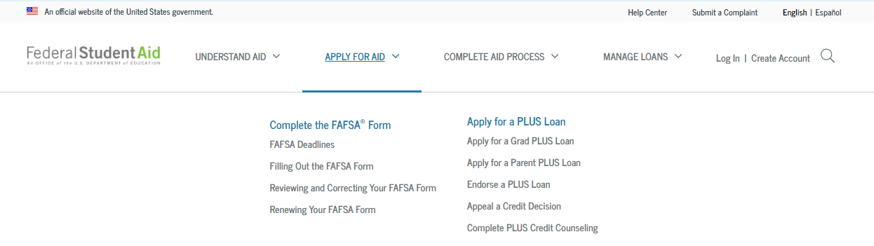

Step 2

- The parent should sign in using their FSA login, the same login that is used by the parent to sign and complete the FAFSA.
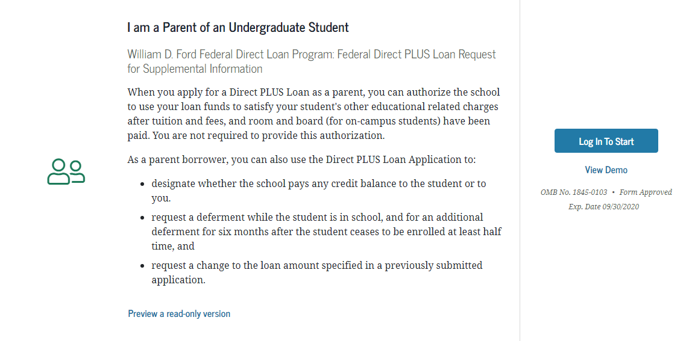

- Select the award year and complete the application carefully.
- After the application is completed, a credit check will perform to inform you if you are approved or denied.

Step 4

- Once the request is submitted, the parent will be notified if the credit has been approved.
- If the parent is denied, the parent may apply with an endorser or may appeal.
- If the parent chooses not to apply with an endorser, the school will be notified of the denial. (If denied the student MAY be eligible for additional unsubsidized loan funds.)



Step 5

- If the Parent PLUS Loan is approved, the Parent will need to complete a Master Promissory Note (MPN). Be sure to complete all of the questions and read all of the terms and conditions. Then sign the MPN by typing your name and clicking "Sign and Submit." A confirmation email will be sent to the email associated with the FSA ID and the school should receive the file within 24 hours.
- A loan will not disburse without a master promissory note and each year a new MPN is required. The MPN is required for each student in school, even if filing under the same parent.

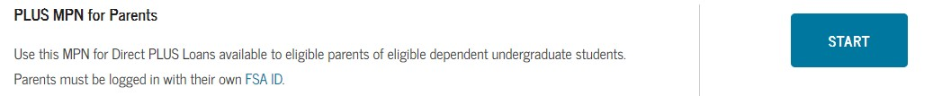

Step 6

•Complete the Parent PLUS Loan counseling (counseling is only required if the PLUS loan was previously denied and approved with an endorser or an appeal was approved).

